

SIMATS ENGINEERING

Saveetha Institute of Medical and Technical Sciences
Chennai- 602105

Student Name: B.Vishnu vardhan Reg. No.:192311267
Course Code: CSA4305 Slot: D
Course Name: INTERNET PROGRAM
Course Faculty: Dr.D.Sudhagar
Project Title: Smart healthcare resource allocation and appointment scheduling system
Module Photographs: (3 photographs –Module Photo, Individual student contribution module work in the project and presentation image)
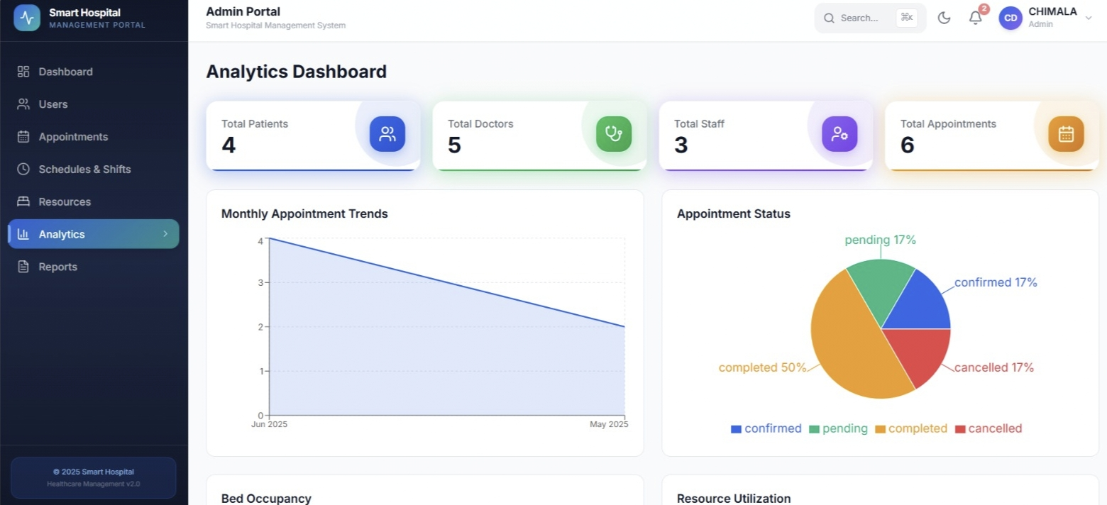
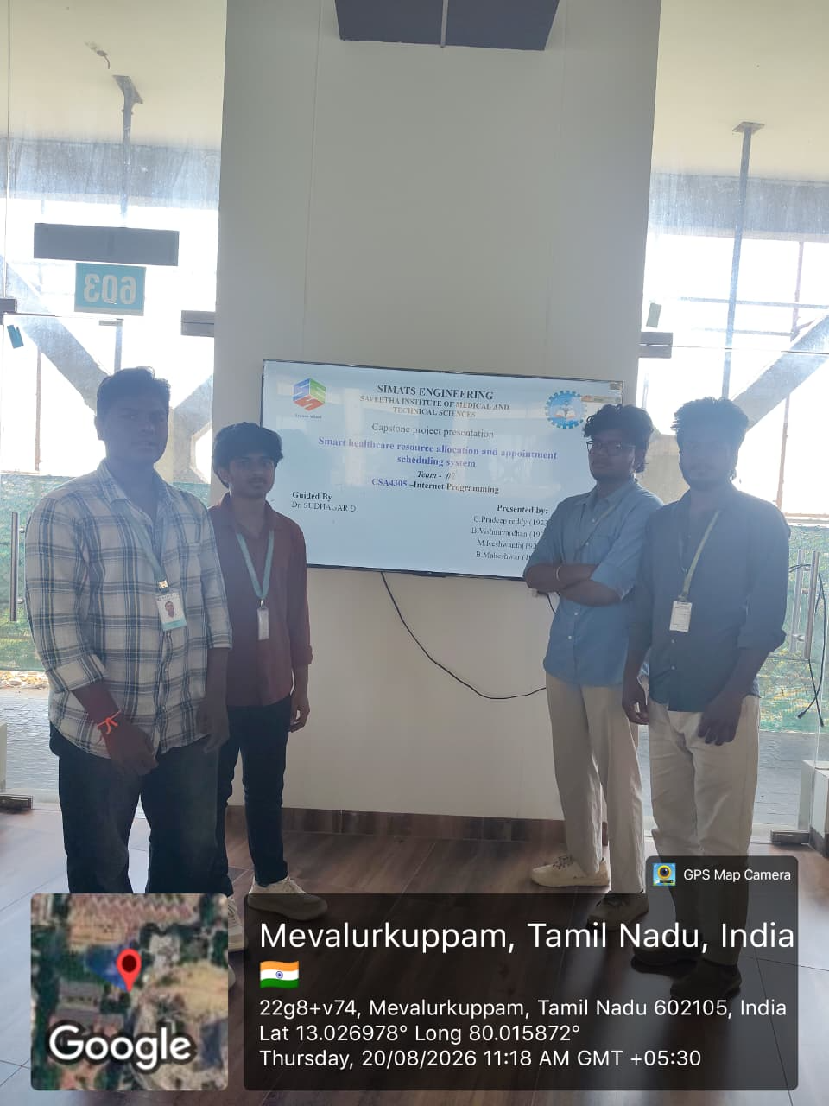
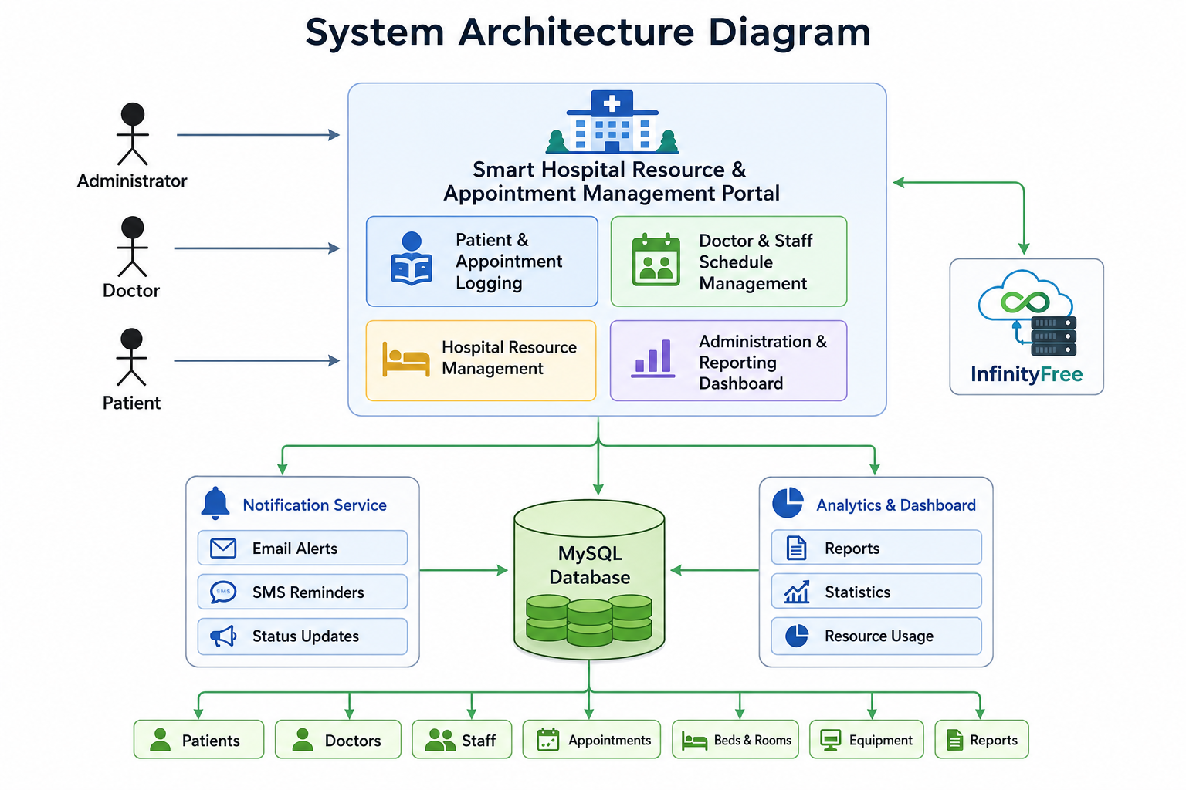
Project Description: Administration & Analytics Dashboard
The Administration & Analytics Dashboard is designed to manage and monitor hospital activities efficiently.
It provides administrators with a centralized view of important hospital information.
The dashboard displays data related to doctors, staff, patients, resources, and appointments.
It helps administrators track daily hospital operations in an organized manner.
Key performance indicators can be displayed using charts, graphs, and summary reports.
The system helps analyze patient visits, staff performance, and resource utilization.
Administrators can easily identify important trends and patterns from the available data.
It provides real-time or updated information to support better decision-making.
The dashboard reduces the need for manual preparation of reports.
It allows authorized users to generate and view different hospital reports.
Data can be filtered according to departments, dates, or specific categories.
The system helps improve transparency and overall administrative control.
Secure access ensures that sensitive hospital information is available only to authorized users.
Analytics can help identify areas that require improvement and better resource planning.

Student Signature Guide Signature

